July 14, 2015

Dear Colleagues;

My name is Judy Bates, I am writing to you today to introduce myself as OCUFA’s 31st President. I officially began my term on July 1, 2015, and I look forward to working with you all in the months ahead.

For those of you whom I have not yet had the pleasure to meet, I am an Associate Professor of Geography in the Department of Geography and Environmental Studies at Wilfrid Laurier University. At Laurier, I have served as President of the Wilfrid Laurier University Faculty Association (WLUFA), and I am currently a Member-at-Large on the WLUFA Executive Committee. For the last two years, I have had the pleasure of being OCUFA’s Vice-President.

Professors and academic librarians in Ontario face a period of unprecedented challenge and change. The Government of Ontario continues to pursue austerity-minded policies, meaning that per-student public funding for universities will continue to decline. Set against this background, we have seen hiring of full-time faculty stagnate and an increased use of contract faculty appointments. As you know, this traps many otherwise promising academics in precarious work. As resources become increasingly scarce, governance of our institutions also becomes strained. Program prioritization and activity-based budgeting cut against important principles of collegial decision making, to the detriment of our universities. In the year ahead, OCUFA will be making university funding, governance, and faculty complement key priorities. I look forward to working on these challenges on your behalf.

OCUFA is also working hard on building pension security for our members. We are currently spearheading a project to explore a multi-employer jointly sponsored pension plan (JSPP) for faculty in Ontario. This work will continue throughout 2015 and beyond. For our members not interested in a JSPP option, we are continuing to advocate for pension regulations and policies that support fair and secure pensions across the university sector. I look forward to continuing my engagement with this vital file.

Finally, I would like to thank outgoing OCUFA President Kate Lawson for her inspirational leadership over the past two years. I will follow her outstanding example as we confront the issues and challenges that lie before us.

Again, I look forward to working with all of you. If you have any questions or comments, please do not hesitate to contact me at [jbates@wlu.ca](mailto:jbates@wlu.ca). You can also contact OCUFA’s Executive Director, Mark Rosenfeld at [mrosenfeld@ocufa.on.ca](mailto:mrosenfeld@ocufa.on.ca).

Yours sincerely,

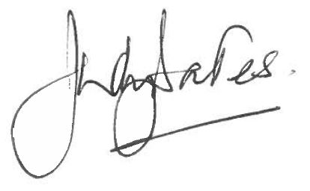

Judy Bates, President of OCUFA

Associate Professor, Wilfrid Laurier University